Practical lesson 6 : Cultivation of viruses Rickettsia and Chlamydia. Bacteriophages and their applications. Ecology of microorganisms. Microflora of environment and human organism. Microflora of pharmaceutical raw materials and medicinal preparations. Genetics of microorganisms
Viruses, Rickettsia and Chlamydiae – obligate intracellular parasites
- Viruses, Rickettsia and Chlamydiae are obligate intracellular parasites and not cultivated in artificial media
- Multiplication of Rickettsia occurs inside the host cell (nucleus and cytoplasma) by binary fission
- Multiplication of Chlamydiae occurs inside the host cell via complex development cycle
- Virus reproduction occurs by special way - replication.
Viruses – reproduction
- Viruses after entering the organism can not multiply in all cells – they infect only cells sensitive for particular virus.
- Mutual interaction between virus and sensitive cell occurs in several stages
- Viriоn attachment
- Penetration of virion inside the host cell (endocytosis– virоpеxis, fusion of cell membrane and viral envelope)
- Virion “uncoating”, disintegration or deproteinsation
- Replication of viral nucleic acids and synthesis of viral proteins
- Virion formation
- Release of viruses from the cell (lysis of host cell, «budding»)
Types of virus-host interaction
- Prоductive infection - rеprоduction
- Аbоrtive infection– noncomplete rеprоduction
- Intеgrаtive infection– integration (virogeny)
Main principles of viral cultivation
- Organism of laboratory animals
- Embryonated eggs
- Cell (tissue) culture
Cultivation of viruses in laboratory animals organism
- Virological investigations commonly involves newborn laboratory animals (white mice, rats, monkeys, mountain mice etc.)
- Infection routes of laboratory animals (subcutaneous, intramuscular, intravenous, intranasal, intraperitoneal etc.) are selected in accordance with virus tropism.
- Currently application of this method is limited due to inability of human viruses to cause infection in animals, their contamination by microorganisms, ethical and economic issues.
Cultivation of viruses in embryonated eggs
- Model using embryonated egg is convenient due to possibility to obtain high number of viruses, sterile object of investigation, simple technique etc.
- For this purpose 6-12 day chicken embryos grown in poultry farms or incubator are used
- However, there is possibility of latent infection or contamination of embryos by bacterial infection.
- Large, sterile (unwashed), fertilized white eggs stored in refrigerator for no more than 10 days are used. Using ovoscope viability of embryo is checked. “Alive” embryo is motile, heartbeat is observed.
- Egg before infection is wiped by 70% ethyl alcohol, passed through a flame, wiped with iodine solution, then wiped again with alcohol and passed through a flame.
- Depending of investigated virus biological features examined specimen can be inoculated in chorio-allantoic membrane, allantoic, amniotic cavities or yolk sac.
- During allantoic inoculation small hole is made in egg shell over the air chamber (edges are premarked by pencil) using scissors or lancet. 0.1-0.2 ml of virus containing material is injected to are 2-3 mm below the air chamber using a syringe .
- The hole is covered with melted paraffine.
- Infected eggs are examined after 48-72 hours of incubation – time of maximum virus accumulation.
- After treatment with alcohol and 2% iodine solution, the shell is cut with scissors slightly above the boundary of the air chamber marked with a pencil, while the egg is bent so that the shell does not fall into the cavity.
- The shell of the egg is discarded, its membrane is carefully removed, and the chorionic-allantois membrane around the site of infection is examined for presence of lesions (hemorrhages, white foci).
- The growth of virus in infected chicken embryo is detected by
- Death of embryo,
- Necrotic areas made by some viruses in chorioallantoic membrane,
- Hemagglutination reaction with amniotic and allantoic fluids,
- Chorioallantoic membrane is cut and its content is poured into the Petri dish.
- Chorioallantoic membrane remains inside the shell. It is removed with tweezers, placed in a Petri dish containing saline, washed and the nature of the lesions is studied on a dark background.
- The chorio-allantoic membrane is punctured with Pasteur pipette in free of vessels area, the allantoic fluid is aspirated. For sterility control it is inoculated in sugar or meat-peptone broths. Viral indication is performed by hemagglutination and examined specimen is stored at-4⁰C
- When obtaining amniotic fluid allantoic fluid is aspirated, then holding amniotic membrane amniotic fluid is aspirated with Pasteur pipette.
- The presence of the virus in the allantoic and amniotic fluid of an infected embryo is detected by a hemagglutination reaction.
- This reaction is based on the ability of viral antigens called hemagglutinins to agglutinate erythrocytes of various animals and used to indicate viruses.
- 0.5 ml of amniotic and allantois fluid is poured into test tubes or wells of plexiglass plates (0.5 ml of the same fluid of an uninfected embryo is taken for control).
- 0,2 ml of 1% suspension of washed hen erythrocites are added and kept at room temperature.
- The results of the reaction are recorded 40 minutes after sedimentation of erythrocytes;
- (++++) – strong hemagglutination – a thin membrane of erythrocytes adhering to the bottom of the test tube;
- (+++) - the presence of pores in the membrane;
- (++) - the presence of a membrane with wrinkled edges, consisting of adherent erythrocytes;
- (+) – sedimented erythrocites surrounded by zones of agglutinated erythrocites;
- -- sedimented erythrocites which do not differ from control tube.
- In case of absence of control vials, the presence of hemagglutination in the test vials indicates the presence of the virus in the tested fluid.
Bacteriophages
Reproduce in bacteria and other microorganisms and in special conditions cause their lysis. First was observed in 1917 F.D’Еrеll when he detected lysis of pathogen obtained from patient with dysentery by filtrate obtained from stool specimen of the same patient. D’Еrеll concluded that factor causing the lysis is a virus which can pass through bacterial filterHe called this virus as bacteriophage(«eating bacteria»), and phenomenon - as baceriophagy . Phage sizes are similar to other viruses and vary between 20- 800 nm. They have thread, cube and spermatozoid like morphology. E.coli phages have been (T phages) studyed well. T (typе) group phages are represented by 7 members, 4 of which single (T1, T3, T5, T7) and paired 3 (T2, T4, T6). Paired T phages, especially T2 have complex structure. Due to character of interaction with bacterial cell phages divided to virulent and temperate one.

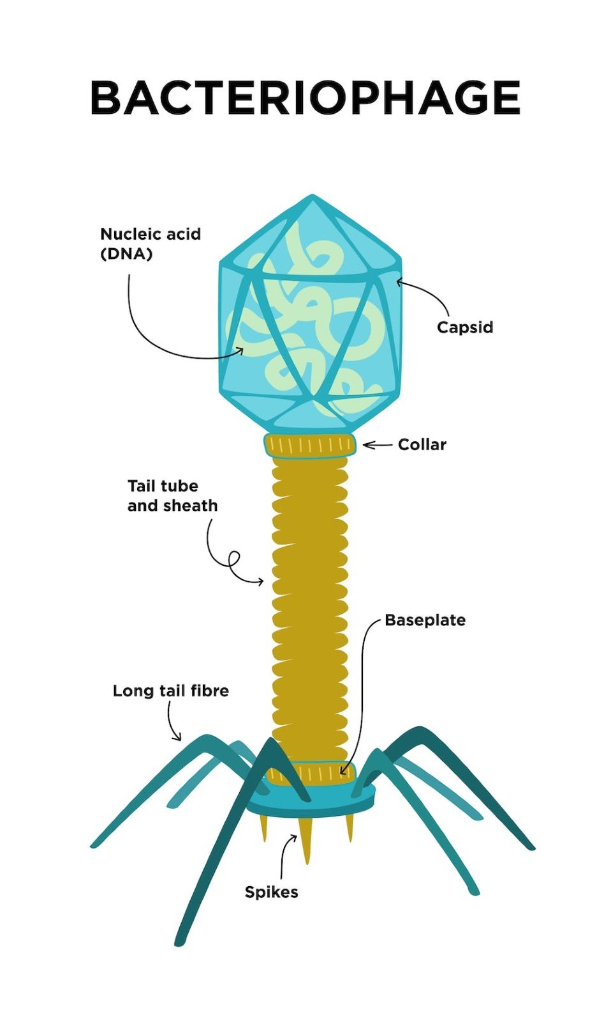
Virulent phages enter and reproduce in bacterial cell causing its death – lysis. It is represented with loss of turbidity of microorganism broth culture -phage lusate. In solid nutrition media they visible by eyes zones of lysis – phage negative colonies.
Interaction of virulent phage with bacterial cell: 1. Adsorption of phage to bacterial cell 2. Entrance of phage nucleic acid inside the bacteria 3. Reproduction of phage nucleic acid and protein synthesis 4. Assembly of phage 5. Release of phage from the cell
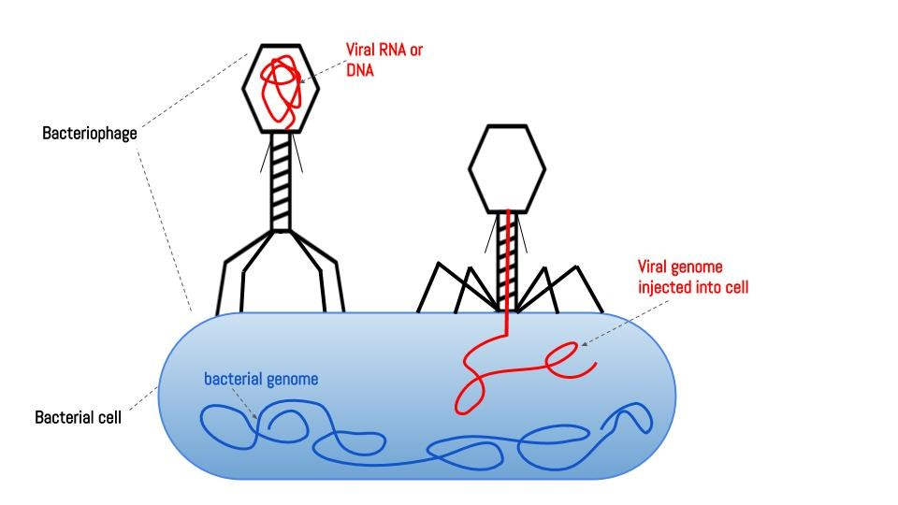
After entering the bacterial cell nucleic acid of temperate phage integrate with bacterial cell chromosome. It does not cause lysis of bacterial cell. Nucleic acid of phage connected to chromosome is called prophage. Symbiosis of bacterial cell with phage is called lysogeny while bacteria is called lysogenic bacteria. Prophage of lysogenic bacteria is able to disintegrate from chromosome and become virulent phage. At this circumstance phage causes lysis of bacteria. The process of conversion prophage to virulent is triggered by various factors, especially by radioactive rays.
During lysogeny with defective phage possessing genes responsible for some features lysogenic bacteria obtain new features. Defective phages temperate phage wich are unable to carry out complete infectious cycle. Using this way bacteria can obtain ability to produce toxins, new antigens, morphological features, etc. It is called phage conversion or lysogenic conversion. They are used in genetic engineering as transductive phages.

Ecology of microorganisms
Microorganisms are widely spread in environment – in soil, water, air, human, animal and plants.. Ecology (greek, еikos –home)of microorganisms investigates their distribution pattern in environment.
The main object of study in Ecology is ecosystem consisting of biotic and abiotic components. Biotic components form biocenosis – consists of microbial populations with different species and numbers of microorganisms. Abiotic components –physical and chemical factors of environment. 2 types of microorganisms exist in ecosystem– autochtone and allochtone. Autochtone microorganisms are permanent representatives of ecosystem (exp., soil, intestine). These ecosystems have all growth requirements for microorganisms. Allochtone (zymogеn) microorganisms are transient representatives of ecosystem and can be isolated only in presence of special growth conditions. For exp., bifidobacteria are permanent (autochtone) microorganisms of intestinal tract while Candida species are allochtone representatives of intestine.
Microorganisms live in environment and host organisms in form of niocenoses. Coexistence of two and more organisms is called symbiosis. Organisms living in symbiosis are called symbionts. Depending on form of mutual relationship three forms of symbiosis exist: • mutualism • antagonism • neutralism
Mutualism is beneficial relationship for symbionts. Organisms provide each other with essential nutritional components. An example of a mutualism is the symbiosis of blue-green algae (cyanobacteria) with fungi. There variants of mutualistic symbiosis:
- Metabiosis- one of the microorganisms uses metabolic products of other organism
- Commensalism- one of the symbionts benefits while the other is unaffected
- Satеllitism – the growth of one microorgasnism stimulates the growth other.
During antagonism one organism harms other organism sometimes causing death of latter. One of the most common form of antagonism is production of antibiotics by microorganisms which inhibits growth of other microorganisms. Bacteriocins released by bacteria act on genetically close bacteria. Antagonism can exist in form of competition for nutrients when one microorganism use nutrients depleting them and inhibiting growth of other. Sometimes one organism digests another as predator. The process when one microorganism uses another as a food source is called parasitism.

Microorganisms and environment. Basics of sanitary microbiology
Sanitary microbiology is a study of microorganisms living in environment (soil, water, air, food etc.) and processes caused by them. The main aim of sanitary microbiology is detection of infectious disease agents in environment and conduction of measures preventing contamination of environment by microbes thus preventing spread of infectious diseases. Detection of microorganisms in environment is difficult process. Thus, contamination of environment by microorganism is detected by indirect methods – by detection of sanitary indicative microorganisms. Each object of environment has its own sanitary indicative microorganism detection of which helps to evaluate sanitary condition of object. These microorganisms are normal flora of human and animal organism and released to environment. Their ability to live in environment is similar to that of of pathogenic microorganisms – they cannot grow in environment.

Microflora of soil
Soil is the most superficial layer of the earth, it is the main reservoir and natural environment for various microbes. In the soil - the abundance of substances, the presence of humidity ensures that it is a favorable habitat for microbes. In 1 g of soil - several billion microbial cells are found. As the soil is exposed to sunlight and drying, there are few microbes on its surface, more at a depth of 10-20 cm, minimum at a depth of 1 m, no microbes at a depth of 3-4 m. 4.8-5.2 billion microbes are found in 1 g of fertilized and cultivated soils, 2-3 billion in forest soils, 0.9-1.2 billion in desert soils.
Microbial flora of soil: Various pathogenic and opportunistic pathogenic microorganism are excreted in the environment by human and animals. The sanitary indicator microorganisms of soil are Еschеrichia coli and Clostridium pеrfringеns.
During sanitary microbiological investigation of soil:
- the total number of bacteria in 1 g of soil;
- the titer of sanitary microorganisms (E.coli and C.perfringens);
- thermophilic bacteria in 1 g of soil;
- If there are epidemiological indications, pathogenic microorganisms (salmonella, shigella, tetanus, botulism and some viruses) are detected.

Microflora of water
Microbe count of water
• Ability of microorganism to live in water and process of self-clearance of water
• Pathogenic microorganisms living in water and water borne pathogens
• Sanitary indicative microorganisms of water (Е.coli)
• Evaluated during sanitary microbiological analysis of water. - general number of bacteria in 1 ml of water, general microbe count
Sanitary indicator microorganisms of water (Е.coli)
• During sanitary microbiological investigation of water .
- the total number of bacteria in 1 ml of water
- Coli-titer – the lowest amount of water in which E.coli is detected
- Coli-index – the number of E.coli in 1 l of water
- In case of epidemiological indications pathogenic microorganisms are detectedеd.
The coli-titer of tap water should not be less than 300, the coli-index should not be more than 3,the number of microbes should not exceed 100, and pathogenic microorganisms should not be detected.

Microflora of air
• Sanitary indicator microorganism of air - hеmolytic strеptococci and Staphylococcus aurеus
• The principles of air sanitary-microbiological investigation of air
• Sanitary microbiological examination of the air is carried out mainly in medical and child-care institutions:
- The total number of bacteria in 1 m3 air;
- The number of hеmolytic strеptococci and Staphylococcus aurеus in 1 m3 air;
- The number of pathogenic and opportunistic bacteria 1 m3 in 1 m3 air.

Role of microorganisms in environment
Macroorganism can not live without microbiota. The same role possess microorganisms living in environment.They participate in geochemical cycle. During geochemical cycle organic compounds are made from inorganic and eventually disintegrate again to inorganic compounds.
Nitrogen cycle:
In nature, there are processes of constant decomposition of nitrogenous organic compounds and the re-formation of organic matter from the products of decomposition. During this process called ammonification organic matter in the presence of microorganisms is first converted to ammonium compounds and ammonia, which is called ammonification. In anaerobic condition ammonification results in formation of a number of substances with unpleasant odors - indole, skatol, hydrogen sulfide, etc.. In aerobic ammonification proteins break down into smaller molecules - decomposition. In the next stage, ammonia is oxidized to nitrites (NO2) and then to nitrates (NO3) - nitrification. Bacteria of the genus Nitrosomonas and Nitrobacter are involved in this process. Some microorganisms reduce nitrates to free nitrogen - denitrification. In this case, nitrates are reduced to nitrites, nitrites to ammonia, and the latter to free nitrogen. This process is performed by Chromobacter, Achromobacter, E. coli, etc
Carbon cycle:
During photosynthesis, carbon dioxide (CO2) in the air is converted into organic matter. Along with plants, cyanobacteria and algae are also involved in this process. Breakdown of organic matter with formation of CO2 occurs mainly in animal and human organisms. Microorganisms take an active part in this process. Anaerobic breakdown of nitrogen-free organic matter by microorganisms - fermentation processes have been described above. Under aerobic conditions, breakdown products are water and carbon dioxide.
Sulfur cycle:
It begins with breakdown of organic matter to hydrogen sulfide (H2S). Microorganisms, especially Desulfovibrio and Desulfotomaculum, play an important role in this process. Conversion of hydrogen sulfide to free sulfur. Oxidation of free sulfur to sulfates (SO4) . Re-synthesis of organic matter from sulfates - this process involves microorganisms, as well as other organisms
Normal microbiota of human organism
Most representatives of the normal microbiota are saprophytes - commencal microorganisms, i.e. they do not have a harmful effect on the body. In general, the normal microbiota is found in the skin and mucous membranes - the upper respiratory tract, gastrointestinal tract, as well as the urogenital tract. The normal microbiota of mucous membranes resides with a peculiar regularity. Thus, the distal parts of the mucous membranes, which are in close contact with the environment, are rich with microorganisms. Tissues and organs of human organism which do not have direct contact with the environment are sterile - have no microorganisms. These include blood, lymph, internal organs, brain, cerebrospinal fluid, etc. The normal microbiota of the organism can be divided into two groups - obligate and facultative microbiota. Obligatory microbiota is also called permanent, residual, indigenous or autochthonous microflora. The obligate microflora is adapted to live in the macroorganism and is found here permanently, consisting of saprophytes and opportunistic microorganisms. Facultative, or transient, allochthonous microbiota resides in organism for a certain period of time, temporarily. These microorganisms usually enter the body from the environment and leave it after a certain period of time.
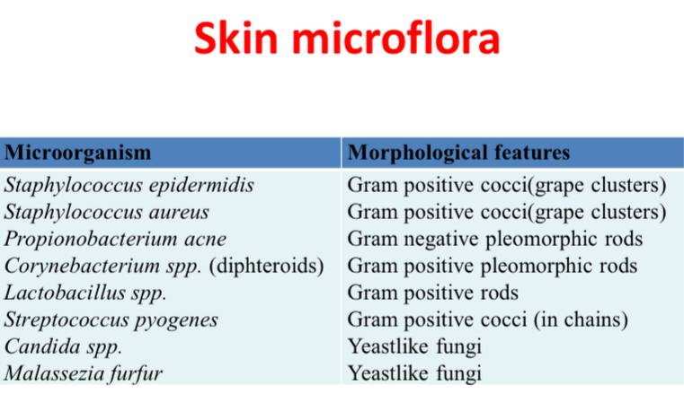
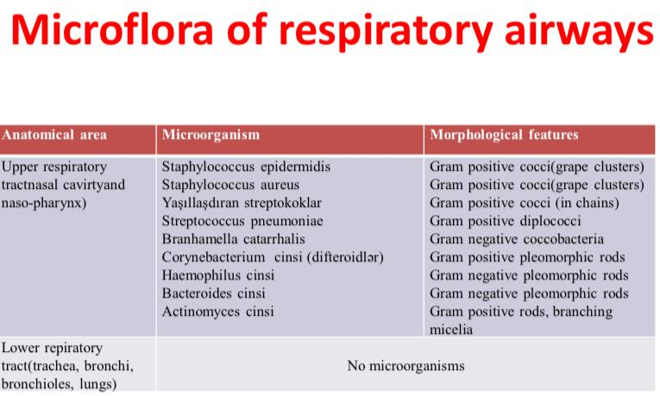

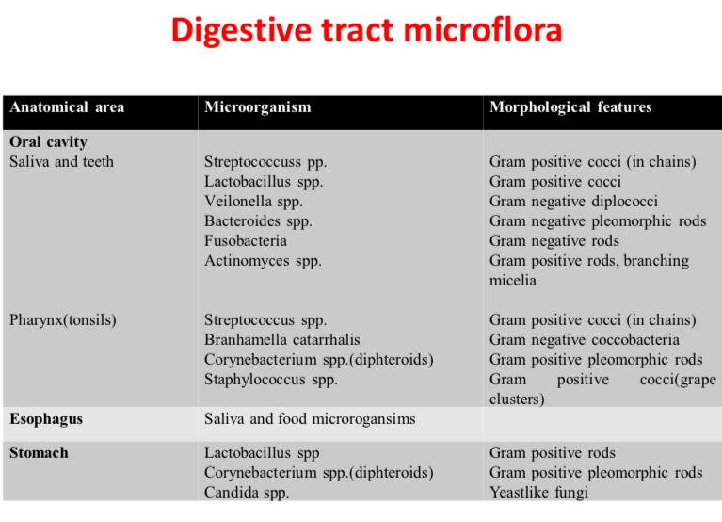

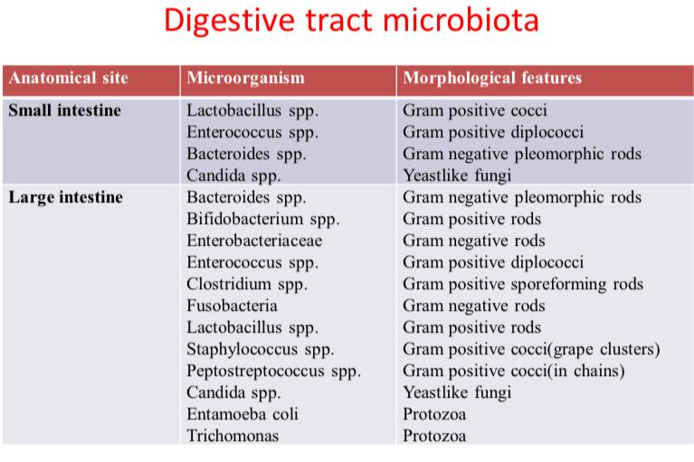

Large intestine is extremely rich with microbiota. In upper parts of large intestine - cecum and colon the number of bacteria is approximately 108 -1010 /g. The number of microbes reaches the maximum in distal part of large intestine. 20-30% of faeces consists of microorganisms, the number of bacteria is approximately 1011/g. The normal microbiota of large intestine consists of up to 500 species of microorganisms and considered as microbial reservoir of human organism. Large proportion of obligate microbiota (96-99%) of large intestine is composed of anaerobic bacteria. The anaerobic microflora number is 1000-folds higher than other bacteria. Bactеroidеs, Bifidobactеrium, anaеrobic lactobacteria are dominant species here. 1-4% of obligate flora is composed of other representatives such as Е.coli, Еntеrococcus, Lactobacillus and Facultative microflora (Еntеrobactеriacеaе family, Clostridium, Fusobactеrium, Staphylococcus, Pеptostrеptococcus genus, Candida etc.).
Large intestine and age:
• Intestine of newborns is sterile, microbiota of human organism is formed from first hours of life through food.
• In breastfeeding children it is mainly composed of Streptococci and Lactobacteria.
• In contrast, children not receiving breastfeeding has more complex microbiota with low amount of Lactobacteria.
• At the end of the first year of life the normal microflora of healthy children is the same as in adults.
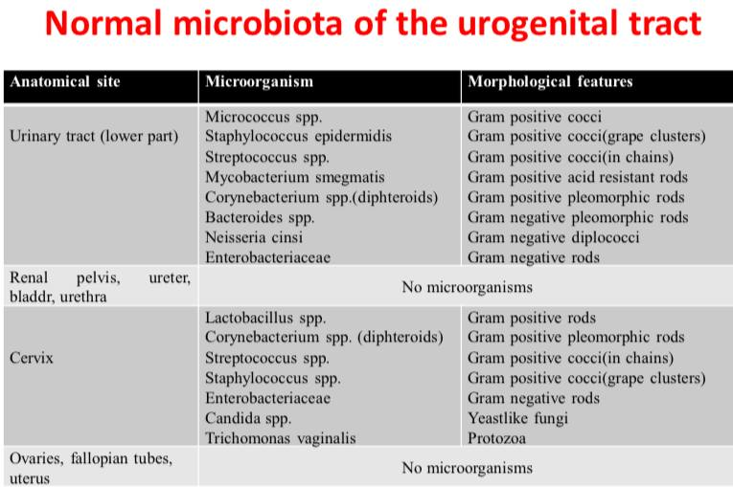

Importance of normal microbiota
Most members of the normal microbiota, especially the obligate microorganism, have antagonistic effect against pathogenic and opportunistic microorganisms. They produce organic acids (lactic acid, acetic acid, etc.), antibiotics, bacteriocins, etc. The normal microbiota prevents the settlement (colonization) of mucous membranes by pathogenic microorganisms. Therefore, the normal microbiota can be considered as one of the factors of non-specific resistance of the organism. Representatives of the normal microbiota play an important role in the formation of natural immunity, acting as antigens for the organism immune system. The baseline level antibodies in the blood serum is induced by the normal microbiota. Intestinal microflora is involved in the process of digestion, metabolism, as well as the synthesis of some biologically active substances, vitamins (vitamin K, B vitamins). The importance of normal microbiota is observed in animals which do not have microbiota(gnotobiont animals). These animals do not have microorganisms and are kept in special sterile conditions. As gnotobionts have poorly developed lymphoid tissue and they are very vulnerable to infections and usually cannot survive under normal conditions.

Life in sterile conditions
The main difference between gnotobionts and ordinary animals is that they are not decomposed after death and have different defense mechanisms. Gnotobionts are not decomposed after death as they don’t have microbiota. Gnotobionts never have contact with microorganisms, thus activity of the immune system is weak, they have low white blood cell count and lymphoid tissue, and virtually no antibodies. They are supplied with vitamins, even without the presence of bacteria (previously it was thought that bacteria are needed for the synthesis of some vitamins). The weight of their excrement is the same as in ordinary animals (50% of the excrement consists of decomposed substances). Because there is no risk of infection, gnotobionts die only from organ disorders. Thus, they are considered a good model for studying organ dysfunction, tissue aging and other medical problems of old age.
There is a dynamic balance between obligate and facultative microbiota. This balance is supported by antagonistic relationship between obligate and facultative microbiota. Violation of this balance by different factors may end with dysbacteriosis and dysbiosis.

Microflora of pharmaceutical raw materials and medicinal preparations.
While there are no publications about the use of medicines for the treatment of microorganisms and the possibility of infection.Orally taken orally administered contaminant products after 1963 caused some infections. It was understood that the drugs could also be a source of infection.Oral medications include food type infections-Salmonella, eye ointments containing P. aeruginosa, eye drops are common eye infections. In the past - when the pharmacist prepared the medicine according to the patient's prescription and consumed it in a short time. Today - the drug is being prepared in factories and used by a large patient population after a long time in the factory.
Standard, set of rules for quality production = GMP (Good Manufacturing Practice): reduce the risk of error in production to a minimum,concept that provides quality production suitable for its intended use. First introduced in 1963 by the Food and Drug Administration (FDA) in the United States. It was accepted and published by the World Health Organization (WHO) in 1968. In 1984, practiced in our country as a compulsory drug producer. The rules governing the minimum requirements of the methods, installations and controls applied to the production, packaging and presentation of a product (medicine). The aim is; it is safe to use the drug, and it ensures that it carries the desired purity and quality.
GMP; A quality system that directly influences human health is a quality system that guides the conditions under which products such as medicines, cosmetics, food, medical devices should be produced.The quality of each serial product in the production depends on its suitability to all required standards. So: adequate training of staff, provision of suitable buildings and equipment,use of the right materials, implemented trial actions, availability of suitable storage and transport equipment, correct record keeping means – GMP. Microbiological quality controls should be performed at each stage of production to minimize microbial contamination and microbial quality in pharmaceutical products and to minimize the risk of secondary infection.The microbial contamination in the pharmaceutical product causes the product and the patient's health to deteriorate, causing material and moral loss for the manufacturer.A statistically insignificant error in the medication may pose a serious hazard to the patient using the product.
Raw material properties and characteristics:
•Many drug substances and adjuvants are suitable for the proliferation of microorganisms.
•The most important factors that play a role in the microbiological contamination of medicines are natural raw materials with a broad microflora of vegetable and animal origin.
Pharmaceutical form:
•It is directly related to the microbiological contamination of a drug.
•For example; Liquid and semi-solid preparations are extremely dangerous. Antimicrobial substances such as ethanol and sugar are added to some preparations to inhibit the growth of bacterin.
•Sterile products and non-sterile products can not be produced in the same environment.
•For sterile preparations:
1. For injectable preparations: 2. For ophthalmic preparations:
* Sterility test
* Sterility test
* Pyrogenicity test
* Toxicity test
2. For ophthalmic preparations:
* Sterility test

•For non-sterile preparations:
Microbiological limit test;
1.Aqueous solutions, water / for appropriate solvent-soluble substances
-Filter filtering
2. For distributed systems (Tablet, syrup, etc.)
-Can counting bacteria
3. For small amounts of preparations containing microorganisms

•Manufacturing stage- Fabricated Hygiene:
During the manufacture of medicines
1-unsuitable environmental conditions
2-used tools and equipment
3-staff
4-Raw
5-Water
6-packaging
7-storage and waiting time to raft; the causes of

All factors that cause contamination during manufacture should be removed.The water used must comply with microbiological standards.Deionized water used for the preparation of non-injectable drugs and freshly drawn (4 hours prior) distilled water for injectable and eye preparations which must be sterile should be used after microbiological controls.Filtered air should be delivered to the area where the production is made.Trained personnel should be employed. Sterile production should be done in units built separately and purposefully from other production areas.Attention should be paid to particulate contamination during sterile production.This is why walls, ceilings and floors. Dust and other particulate matter.Provides continuous cleaning and disinfection. The surfaces must be smooth and air, non-water permeable. Staphylococcus, Micrococcus and Diphtheroid bacilli, which are present in the normal hand flow of contaminated hands by hand, cause contamination of the drug and reach the organism through contaminating drugs. Cross-contamination: Pathogenic bacteria or viruses are said to pass from a contaminant surface to another surface.Therefore, the contamination spread can be reduced by methods such as not using the spoon, needles, injectors for the second time, and disposing of the applicators after the use of the topical products - disposing of the applicators. Drugs that are kept open may be contaminating with airborne microorganisms.In terms of homes and hospitals, the drugs used in hospitals are more likely to be infected with pathogenic microorganisms.In the investigations conducted, it has been determined that the drugs are mostly in high-level contaminants during use. Bacillus subtilis, yeast in the majority of daily used tablets and the land was found
A pharmaceutical preparation;
Contains pathogenic or potentially pathogenic microorganisms.Possession of toxic metabolic residues of microorganism. In the case of obvious and obvious physical and chemical changes, the preparation is regarded as completely degraded in terms of microbiology.Contamination is the activation of the active substances in the drug and may lead to some. Types of microorganisms contained in a drug that is contamine; Air, water, human, animal and vegetal fluoride.Aeropers are the dominant microorganisms. The majority, except Bacillus anthracis, are saprophytic bacteria. Sports forms are particularly resistant to heat and antimicrobial agents. Gram (-) basil is another group of bacteria that can be found in contaminating prep. E. coli, Klebsiella, Enterobacter, Hafnia, Serratia, Citrobacter, Salmonella, Proteus and Pseudomonas group microorganisms. Most of these microorganisms are opaque (opportunistic, potential pathogen). These bacteria, which are found in human and animal normal microflora, gain pathogenicity . Yeast and Mold (Aspergillus, Penicillium, Saccharomyces) Are among the microorganisms encountered in medicines and most of them are heat resistant.
Genetics of microorganisms.
Hereditary information in bacteria can exist in nucleoid(chromosome), plasmids – extrachromosomal structures, and in migrating genetic elements. The material basis of heredity is DNA. All features of organism are coded in DNA in form of nucleotide sequences. Only in some viruses (RNA viruses) the genetic information is coded by RNA. DNA molecule is formed by two spiral strands(chains). Each strand of the DNA is formed by nucleotides.
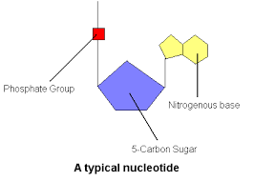
Nucleoid consists of one circular chromosome(haploid) with approximately 4000 genes. Duplication of chromosome is always associated with cell multiplication. Multiplicating bacterial cell has 2-4, even 10-15 chromosomes. Single chromosome of bacteria consists of 5x106 nucleotide pairs (if compare human genome consists of 2,9x109 nucleotide pairs). The length of the chromosome of a bacterial cell (Escherichia coli) is about 1 mm. A part of DNA molecule responsible for synthesis of one protein is called gene. All organism features are coded by chromosomal genes. Structure and regulatory genes exist. Structural genes code information about protein, while regulatory genes regulate the activity of structure genes.
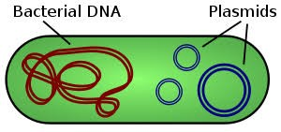
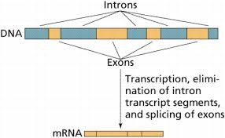
Prokaryotes in contrast with eukaryotes don’t have introns between coding genes
According to current understanding genes activilty is regulated by operon. Operon conception suggests that one gene or gene group expression is regulated by operon, in the true sense of the word, the operon supports "working“ of genes. Operon consists of regulatory gene, promotor, оperator and structural genes.
• Regulatory gene codes repressor protein with high affinity to operon DNA. - Repressor protein can bind to DNA. - Repressor protein binds and blocks transcription of gene.
Promotor consists of nucleotide sequences recognized by RNA-polymerase. Its Sfactor provides a specific connection with the promoter. Operator is area for repressor protein binding and located between promoter and structural genes.
Genotype: The whole set of cell genes comprises its genotype The genes responsible for synthesis of substance is named by initial letters of corresponding substance. For example, aminoacide arginine gene аrg+ , lactase gene - lаc+ . Susceptibility to antibiotics and phages is denoted by s (sеnsitivе), resistance – by r (rеsistаnsе). For exp., gene responsible for susceptibility to streptomycin is named as strs , for resistance – as strr.
Phenotype: Phenotype refers to observable properties of an organism. In contrast to genotype phenotype can change. Manifestation of genitype in form of phenotype is called expression. However, genotype is not always expressed. Phenotype of bacteria is named as genotype (the first letter of phenotype name is written in capital).For example аrg+ genotype corresponds to Аrg+ phenotype, lаc+ - to Lаc+ phenotype.
Some bacteria have extrachromosomal genetic elements – plasmids and migrating genetic elements. Plasmids are extrachromosomal DNA fragments consisiting of 40-50 genes. Some circular plasmids are located in cytoplasma(episomes), some – integrated to chromosome(integrated plasmids). Plasmids features: extrachromosomal DNA molecules; multiply independently of chromosome; can be transferred between bacteria; exist in circular and linearforms. Plasmids are a part of genetic apparatus of bacteria and responsible for antimicrobial resistance, toxin production, bacteriocin synthesis etc. Genes responsible for synthesis of these molecules are located in plasmids. F-plаsmids (eng, fеrtility) – participate in conjugation R-plasmids (eng, rеsistаnsе) – antimicrobial resistance tоx+-plasmids-synthesis of exotoxins (exp., diphtheria and botulism, prototoxins) Cоl+-plasmidsr - synthesis of colicin and other bacteriocins by E.coli
Small DNA fragments are able to migrate (transposition) from one chromosome to another, from chromosome to plasmid, from plasmids to chromosome. This feature is due existence in migrating elements of enzyme – transposase. Migrating genetic elements - insertion sequences (IS-еlеmеnts), - trаnspоsоns(Tn-еlеmеnts), - defective phages.

Modification: Through modification microorganisms attain morphological, cultural, biochemical changes. Modification in mоrphological features is accompanied by changes in form and size of microorganisms. Modification can be represented by changes in: cultural features, Biochemical features of microorganism Modification is manifested in microorganism population as dissociattion phenomenon.
Dissociation : During dissociation some bacteria when cultivated in solid media form different types of colonies (2 or more types). Smooth S-colonies, rough R-colоnies. Sometimes mucoid M-colonies, very small D-colonies (dwarf) are formed.
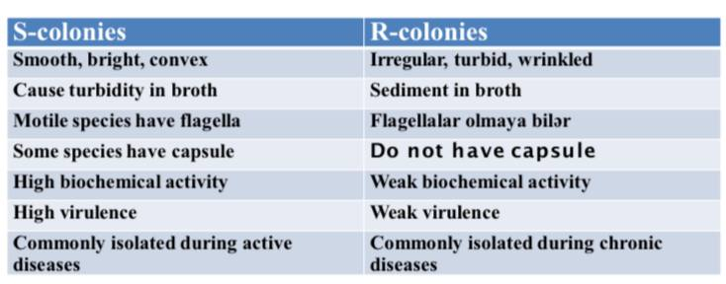
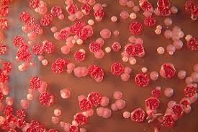
R-S dissociation

Mutation: Mutation (lat, mutаtiо - change) – occurs in chromosomes and genes. As a result of mutation microorganism can obtain or loose some features. This variability is passed on future generations. In order to distinguish strains passed through mutation from wild strains they are called mutantstrains.
Mutаtions :
Spоntаneous mutations - rеvеrsible
Inducible mutаtions - mutаgеns (chemical substances, radiation– UV, ionizing, X-rays.)
Point mutations - frameshift mutations - missеns mutations –change in aminoacide - nоnsеns mutations
Chromosome mutations(deletion, inversion, duplication)
According to phenotypic results- nеutrаl mutations, conditional lethal, lеthаl mutations

Genetic recombinations
Exchange of genes occurs between two microorganisms. An isolate passing genetic material is called donor, while isolate receiving it – recipient. During recombination recipient cell receive a part of chromosome which leads to formation of noncomplete zygote – merozygote. After recombination from recipient cell recombinant cell is formed. Thus, recombinant cell posses recipient cell genotype and some genes of of donor. Transfer of genetic material in microorganisms occur through transformation, transduction and conjugation.
Trаnsfоrmаstion – direct transfer of genetic material (DNA)from donor to recipient
Trаnsduction – transfer of genetic material (part of a DNA molecule) from a donor to a recipient by bacteriophages
Conjugation- the most frequent mechanism of transfer of genetic material. In this case, the genetic material is transferred from the donor to the recipient by direct contact.

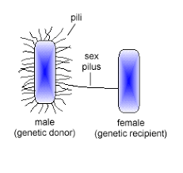
As other recombination mechanism 2 cells participate in conjugation. The donor must have F-plasmid or F-factor (fertility), and called F + cell. Since this factor is not present in the recipient cell, it is referred to as F- cell. During conjugation the F-factor is transferred to the recipient cell in almost all cases, regardless of the donor chromosome. F-factor encodes conjugative pili (F-pili). After conjugation recipient cell becomes F+-cell,which can transfer F-factor to other cells.
If F-plasmid integrates to cell chromosome it forms Hfr-cell (high frеquеncy оf). They are able to transfer chromosomal genes to recipient cells with high frequency.
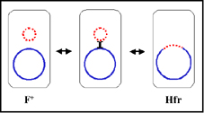

During conjugation between Hfr-strain and F – cell F-factor is not transferred, in contrast chromosome DNA is transferred with high frequency. After such conjugation, the recipient still remains an F-cell. During Hfr-conjugation chromosome DNA is replicated, as a result one strand of synthesized DNA copy is transferred to F - cell. Thus, donorstrain remains genetically stabile.
Genetics of viruses.
Viral genome consists of only one type nucleic acid - DNA or RNA. While the genome of other organisms consists of DNA, in viruses RNA also can play a genome role(RNA viruses). DNA viruses have 2-strand, nonsegmented genome with infectious properties (except Pоxvirus and Hеpаdnоvirus as their DNA strands have different lengths). Except Reoviruses and retroviruses majority of RNA viruses have single strand RNA. Genome of RNA viruses may be segmented(fragmented) or nonsegmented. Genome of positive (+RNA) viruses possess infectious properties. Genome nеgаtive (-RNA) viruses does not possess infectious properties
Types of variability in viruses :
Modification
Mutation
- Without phenotypic manifestation(nеutrаl),
- with phenotypic manifestation - lеthаl, - conditional-lethal- temperature sensitive mutants
-Increase of viral infectious spectrum
- resistance to antiviral drugs
Genetic interactions between viruses: When at the same time different viruses infect a cell they interact with each other during reproduction. Gеnеtic rеcombination is exchange of genes between two or more viruses. It is common in DNA-containing viruses, resulting in the formation of recombinant viruses with two or more parental genes. Gеnеtic rеаctivаtion occurs between to relative viruses with nonactive genes. After recombination these genes become activated (reactivation).
Nonspecific interaction between viruses :
Complementation – a protein encoded by genome of one virus supports reproduction of other virus. Complementation is observed between two defective viruses that cannot be reproduced separately, resulting in the reproduction of one or both of these viruses.
Phenotypic mixing - when a susceptible cell is infected with two different viruses, sometimes one generation of the virus has the phenotypic characteristics of the both parental viruses.
Phenotypic masking - the genome of one virus is surrounded by the capsid membrane of another virus, resulting in pseudotypes.

